Link to repository:

Evidence from the end of the module Create a web API with ASP.NET Core controllers showing the existing pizzas and your additional pizza:
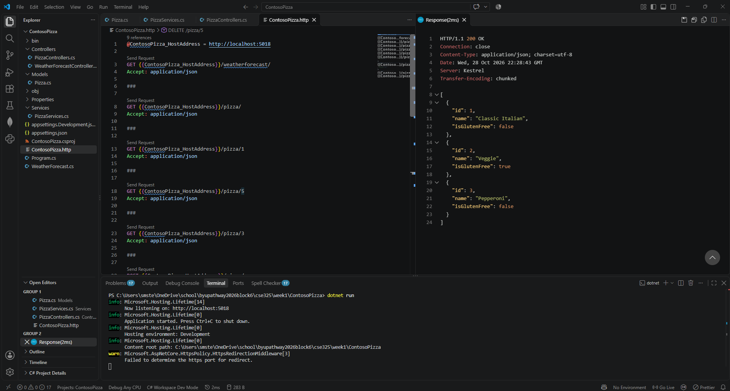

For each operation (GET, POST, PUT, and DELETE), the request you sent, the response you received, and the returned status code.
GET {{ContosoPizza_HostAddress}}/pizza/
Accept: application/json
HTTP/1.1 200 OK
Connection: close
Content-Type: application/json; charset=utf-8
Date: Wed, 28 Oct 2026 22:36:27 GMT
Server: Kestrel
Transfer-Encoding: chunked

[
{
"id": 1,
"name": "Classic Italian",
"isGlutenFree": false
},
{
"id": 2,
"name": "Veggie",
"isGlutenFree": true
},
{
"id": 3,
"name": "Pepperoni",
"isGlutenFree": false
}
]

GET {{ContosoPizza_HostAddress}}/pizza/3
Accept: application/json
HTTP/1.1 200 OK
Connection: close
Content-Type: application/json; charset=utf-8
Date: Wed, 28 Oct 2026 22:36:46 GMT
Server: Kestrel
Transfer-Encoding: chunked

{
"id": 3,
"name": "Pepperoni",
"isGlutenFree": false
}

POST {{ContosoPizza_HostAddress}}/pizza/
Content-Type: application/json

{
"name": "Hawaiian",
"isGlutenFree": false
}
HTTP/1.1 201 Created
Connection: close
Content-Type: application/json; charset=utf-8
Date: Wed, 28 Oct 2026 22:38:16 GMT
Server: Kestrel
Location: http://localhost:5018/Pizza/6
Transfer-Encoding: chunked

{
"id": 6,
"name": "Hawaiian",
"isGlutenFree": false
}

GET {{ContosoPizza_HostAddress}}/pizza/
Accept: application/json
HTTP/1.1 200 OK
Connection: close
Content-Type: application/json; charset=utf-8
Date: Wed, 28 Oct 2026 22:39:02 GMT
Server: Kestrel
Transfer-Encoding: chunked

[
{
"id": 1,
"name": "Classic Italian",
"isGlutenFree": false
},
{
"id": 2,
"name": "Veggie",
"isGlutenFree": true
},
{
"id": 3,
"name": "Pepperoni",
"isGlutenFree": false
},
{
"id": 6,
"name": "Hawaiian",
"isGlutenFree": false
}
]

PUT {{ContosoPizza_HostAddress}}/pizza/6
Content-Type: application/json

{
"id": 6,
"name": "Hawaiian Deluxe",
"isGlutenFree": false
}
HTTP/1.1 204 No Content
Connection: close
Date: Wed, 28 Oct 2026 22:39:57 GMT
Server: Kestrel

GET {{ContosoPizza_HostAddress}}/pizza/
Accept: application/json
HTTP/1.1 200 OK
Connection: close
Content-Type: application/json; charset=utf-8
Date: Wed, 28 Oct 2026 22:40:20 GMT
Server: Kestrel
Transfer-Encoding: chunked

[
{
"id": 1,
"name": "Classic Italian",
"isGlutenFree": false
},
{
"id": 2,
"name": "Veggie",
"isGlutenFree": true
},
{
"id": 3,
"name": "Pepperoni",
"isGlutenFree": false
},
{
"id": 6,
"name": "Hawaiian Deluxe",
"isGlutenFree": false
}
]
GET {{ContosoPizza_HostAddress}}/pizza/6
Accept: application/json
HTTP/1.1 200 OK
Connection: close
Content-Type: application/json; charset=utf-8
Date: Wed, 28 Oct 2026 22:40:43 GMT
Server: Kestrel
Transfer-Encoding: chunked

{
"id": 6,
"name": "Hawaiian Deluxe",
"isGlutenFree": false
}

DELETE {{ContosoPizza_HostAddress}}/pizza/6
HTTP/1.1 204 No Content
Connection: close
Date: Wed, 28 Oct 2026 22:41:04 GMT
Server: Kestrel

GET {{ContosoPizza_HostAddress}}/pizza/
Accept: application/json
HTTP/1.1 200 OK
Connection: close
Content-Type: application/json; charset=utf-8
Date: Wed, 28 Oct 2026 22:41:18 GMT
Server: Kestrel
Transfer-Encoding: chunked

[
{
"id": 1,
"name": "Classic Italian",
"isGlutenFree": false
},
{
"id": 2,
"name": "Veggie",
"isGlutenFree": true
},
{
"id": 3,
"name": "Pepperoni",
"isGlutenFree": false
}
]

A text copy of your working sales summary function from the Work with files and directories in a .NET app module:
void GenerateSalesSummary(IEnumerable<string> salesFiles, string reportPath)
{
var report = new StringBuilder();
double grandTotal = 0;
var details = new StringBuilder();

foreach (var file in salesFiles)
{
string salesJson = File.ReadAllText(file);
SalesData? data = JsonConvert.DeserializeObject<SalesData?>(salesJson);
double fileTotal = data?.Total ?? 0;

grandTotal += fileTotal;
details.AppendLine($" {Path.GetRelativePath(storesDir, file)}: {fileTotal:C}");
}

report.AppendLine("Sales Summary");
report.AppendLine("----------------------------");
report.AppendLine($" Total Sales: {grandTotal:C}");
report.AppendLine();
report.AppendLine(" Details:");
report.Append(details);

File.WriteAllText(reportPath, report.ToString());
}

